**Task 2: Extended Response**

Mark: __________/20

**Year 11 Human Biology 2017**

Answer the two questions below on the lined paper provided. You can choose how to structure you answer, and may include labelled diagrams or tables if appropriate.

**Question 1)**

1. Discuss the structural and chemical properties of enzymes. (6 marks)

• Enzymes are proteins

• Have an active site that is specific to a particular substrate/s

• After the reaction the enzyme is unchanged

• Are biological catalysts & increase the rate of reaction

• Lower the activation energy required for a reaction to occur

• Can become denatured at high temperatures or pHs above or below the optimum range.

• Denatured enzymes have had the their active site changed and cannot participate in reactions

**Must have at least 6 points**

1. Discuss in detail the ‘lock and key model’ of enzyme action. (4 marks)

• Substrate binds to an active site

• Substrate fits exactly into the active site, like a lock and key

•Substrate/Product complex formed

• The enzyme remains unchanged after the reaction

• Enzyme’s shape is rigid (doesn’t change)

• Good diagram eg.

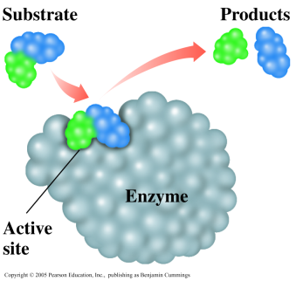

**Question 2)**

For each of the following sections of the graph, describe and explain the lactic acid concentration in the test subject's bloodstream, including relevant respiration word equations where appropriate. (6 marks)

(i) From time A to point B

• Low levels of lactic acid in blood due to predominately aerobic respiration taking place in muscle cells. (1 mark)

• Equation for aerobic respiration:

Glucose + Oxygen 🡪 Carbon dioxide + water + 38 ATP (1 mark)

or

Glucose 🡪 Pyruvate (+2 ATP) 🡪 Carbon dioxide + water + 36 ATP - with use of TCA etc. cycle & electron transfer chain.

(ii) From point B to point C

•Due to not enough Oxygen reaching mitochondria/cells, (1 mark)

•Anaerobic respiration increases, resulting in increased levels of lactic acid in muscle cells (1 mark)

•Equation for anaerobic respiration:

Glucose 🡪 Pyruvate (+2 ATP) 🡪 Lactic Acid (1 mark)

(iii) From point C to point D

•Lactic Acid levels dropping as it is taken to the liver and broken down

(1 mark)

**Question 2b)**

1. Explain why cellular respiration is essential for maintenance of life. (4 marks)

Why is it essential?

* ATP is an energy source essential for cellular activities **1 mark**

Such as: **Max 3 marks**

* Active transport
* Protein synthesis
* Anabolic reactions
* DNA replication / cell division
* Maintaining cell organisation
* Transporting substances within the cell
* Movement of whole cell
* Transmitting nerve impulses